Installation of Node.js
NVM is known as Node Version Manager, similarly to RVM (Ruby Version Manager) for Ruby language. NVM provides an option for the easy installation of Node.js. You can also install a specific Node.js version or multiple Node.js versions on the same system using nvm and use the required version for the application.

Step 1 – Install NVM
First, make sure you have curl installed on your system:
sudo apt update && sudo apt install curl -y
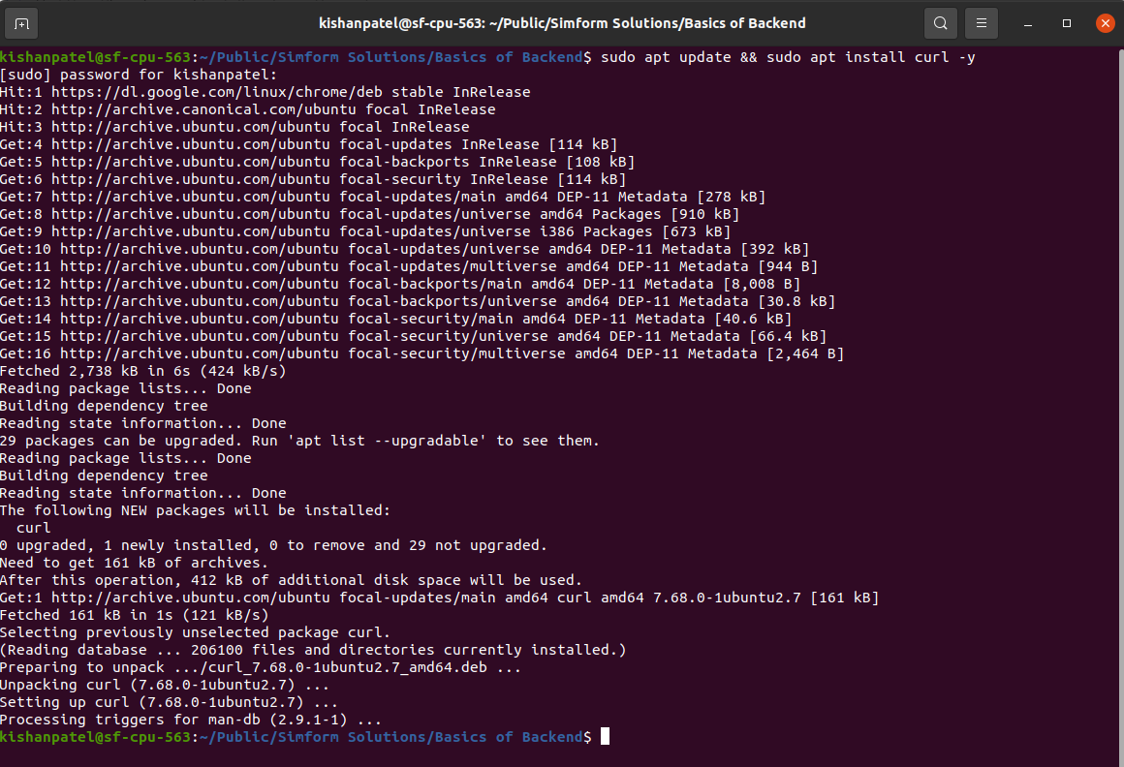
- Next, run the following command to configure nvm on your system for current logged user.
curl https://raw.githubusercontent.com/creationix/nvm/master/install.sh | bash
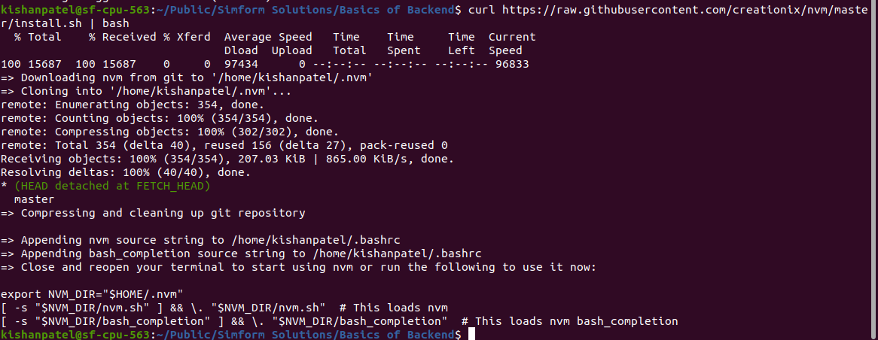
- Reload system environment using this command. It will set the required environment variables to use nvm on the system.
  - Debian based systems:
source ~/.profile
  - CentOS, Fedora and Redhat systems:
source ~/.bashrc

Step 2 – Find Available Node.js Version
At this point, you have installed nvm on your system for the current user. Now find out the available version of Node.js to install. Use ls-remote option to list versions.
nvm ls-remote
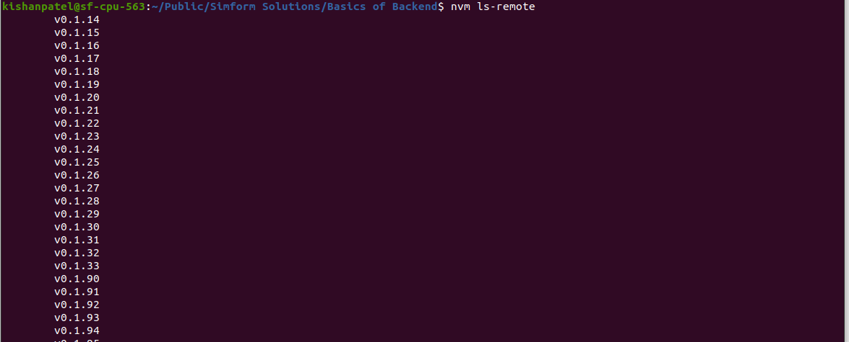

Step 3 – Installing Node.js with NVM
Now install the node.js version you need to use for running the node.js application. Below command will install node.js 14.16.0 the LTS release on your system.
nvm install v16.14.0
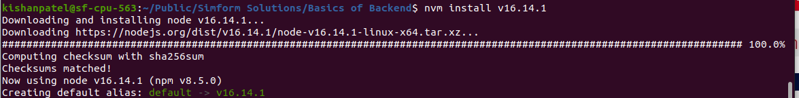

To Remove Unused Node.js Version
This command will provide a list of installed versions of node.js on your system.
nvm list
You can remove any unused version from your system. For example, to remove Node.js version 9.5.9 execute the following command:
nvm uninstall v9.5.0

